Seller’s Name & Phone Number: ______________________________________________________
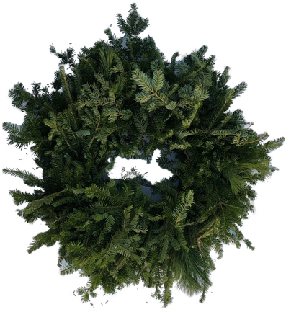  22-24” Plain Wreath  $________ | 34-36” Plain Wreath  $________ | 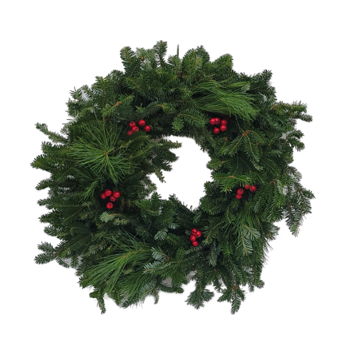  22-24” Wreath w/ Berries  $________
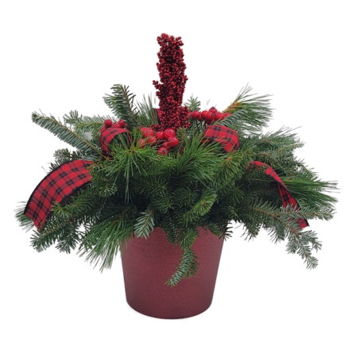  22x20” Table Top  $________ | 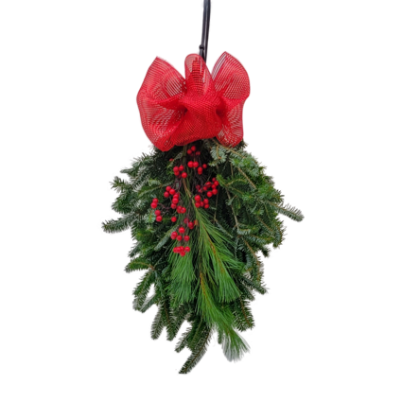  29” Door Swag  $________ | 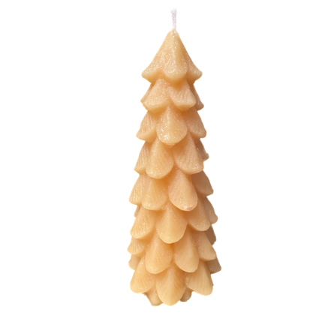  100% Beeswax Candle  $________

Name | Medium Wreath | Large Wreath | Wreath w/Berries | Table Top | Door Swag | Beeswax Candle | Total

